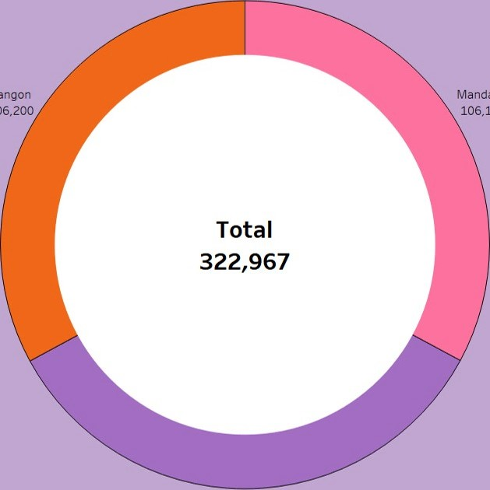

Yangon

106,200

Mandalay

106,198

Naypyitaw 110,569

AREA CHART City

 Mandalay Naypyitaw

Yangon

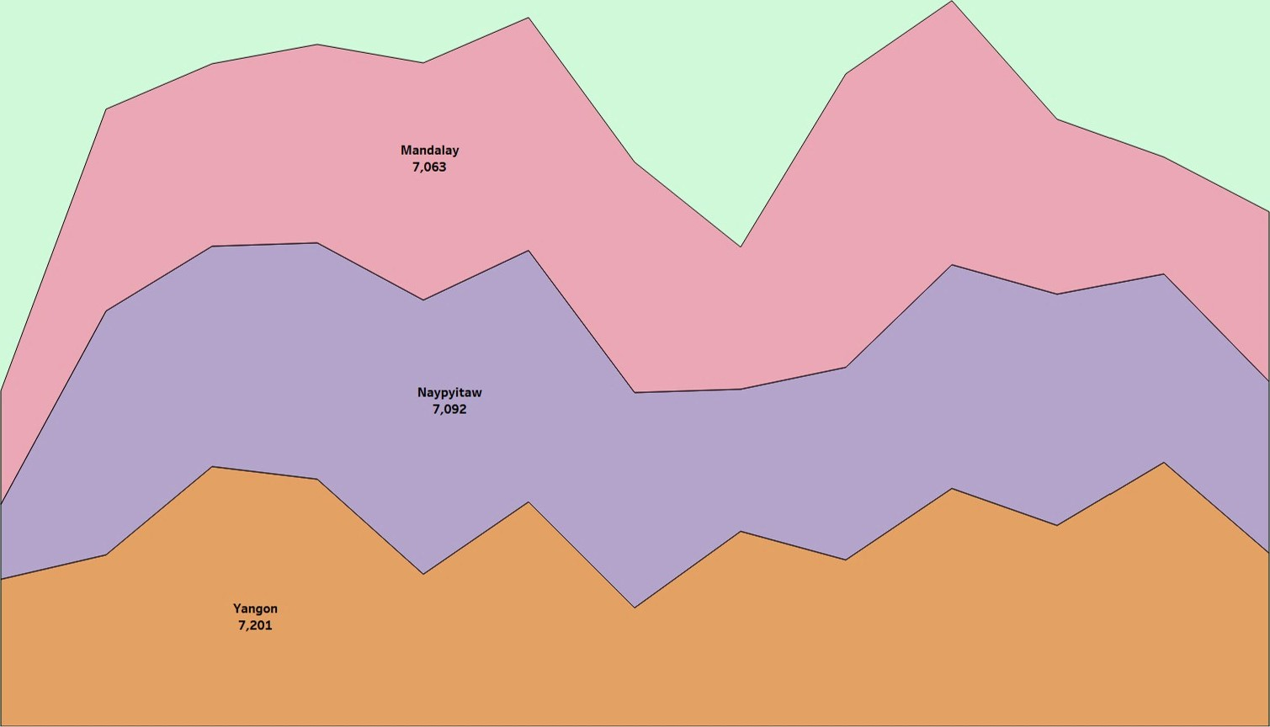

30

Dec

18

6

Jan

19

13

Jan

19

20

Jan

19

27

Jan

19

3

Feb

19

10

Feb

19

17

Feb

19

24

Feb

19

3

Mar

19

10

Mar

19

17

Mar

19

24

Mar

19

Week of Date

Highlighted Table

|  |  |  |  |
| --- | --- | --- | --- |
| Product line |  | City | |
| Mandalay | Naypyitaw | Yangon |
| Electronic accessories | 97% | 108% |  |
| Fashion accessories | 87% | 109% | 105% |
| Food and beverages | 94% | 112% | 92% |
| Health and beauty | 116% |  | 83% |
| Home and lifestyle | 104% |  | 102% |
| sports and travel |  | 105% |  |

Text Table

|  |  |  |  |  |  |
| --- | --- | --- | --- | --- | --- |
| City  Mandalay  Naypyitaw  Yangon | Product line | Gross Income | Tax 5% | Total | Unit price |
| Electronic accessories | 312 | 812 | 17,051 | 2,742 |
| Fashion accessories | 782 | 782 | 10413 | 3,400 |
| Food and beverages | 725 | 725 | 15,215 | 2,777 |
| Ho me and lifestyle | 836 | 836 | 17 549 | 2,776 |
| Sports and travel  Electronic aocessories | 952    903 | 952    903 | lg,988    18.969 | 3,700    3,070 |
| Fashion accessories | 1,027 | 1,027 | 21,560 | 3,883 |
| Food and beverages | 1,132 | 1,132 | 23,767 | 3,780 |
| Ho me and lifestyle | 662 | 662 | 13,8g6 | 2,445 |
| Sports and travel    Electronic accessories | 751 | 751    872 | 15,762    18,317 | 2,480    3,2g2 |
| 372 |
| Fashion accessories | 778 | 778 | 10333 | 2,890 |
| Food and Irverages | 317 | 817 | 17,163 | 3,18g |
| Ho me and lifestyle | 1,067 | 1,067 | 22,417 | 3,630 |
| Sports and travel | 923 | g23 | lg,373 | 3,281 |

Word Cloud  Product line

* Fashionaccessories

Health and beauty Food and beverages

Health and beauty

* Home and lifestyle Sports andtravel

49, 194

# Home and lifestyle 53,862

Electronic accessories

54,338

Sports and travel Fashion accessories

# 55,123 54,306

Sheet 1 Sheet 2 Sheet 3 Sheet 4 Sheet 5 Sheet 6 Sheet 8 Sheet 10 Sheet 11

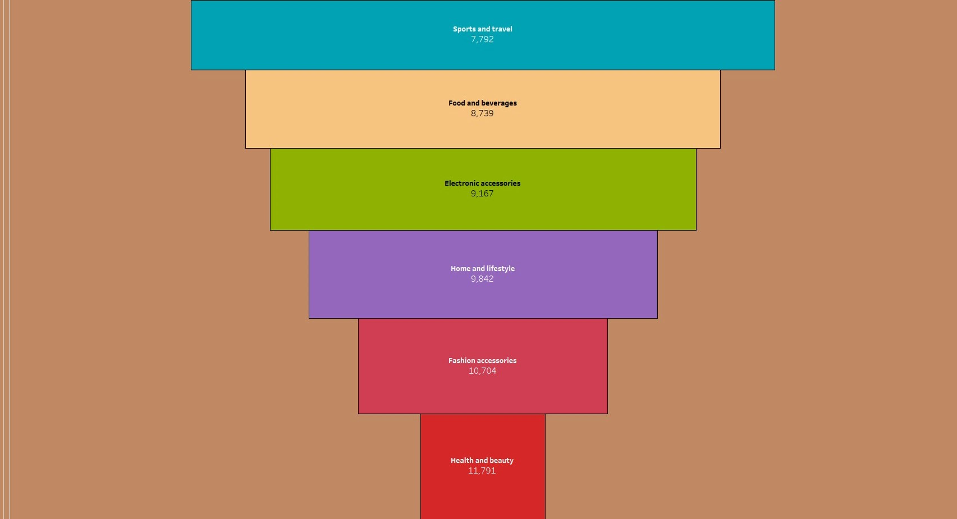Funnel Chart

Product line



2400+

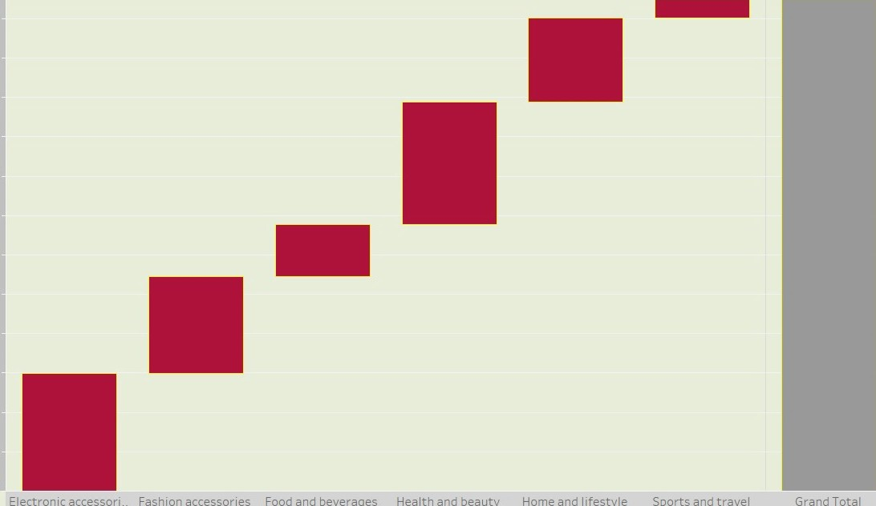

Electronic

accessori

Fashion

accessories

Food

and

beverages

Health

and

beauty

Home

and

lifestyle

Sports

and

travel

Grand

Total

2200

1800.

1600

6

0 1400,

1200

10000

800.

600

4000

200